The following definitions are intended as a guideline to prioritize requirements.
• Priority 1 – Create FLUME job for fetching log files from spool directory the data
• Priority 2 – MapReduce/pig job to preprocess
Download the dataset using the below link:
Link:
https://drive.google.com/file/d/0Bxr27gVaXO5sUjd2RWFQS3hQQUE/view?usp=sharing
Refer the below steps to understand the actual steps to create the
above project.
Step 1:
Copy dataset from local file system to HDFS using flume.
Note: use the conf file by downloading from below link.
Click here to download
Command:
flume-agent agent –n agent1 –c conf –f <path to filecopy.conf>

1. Flume Installed and AcadgildLocal.conf moved to config directory

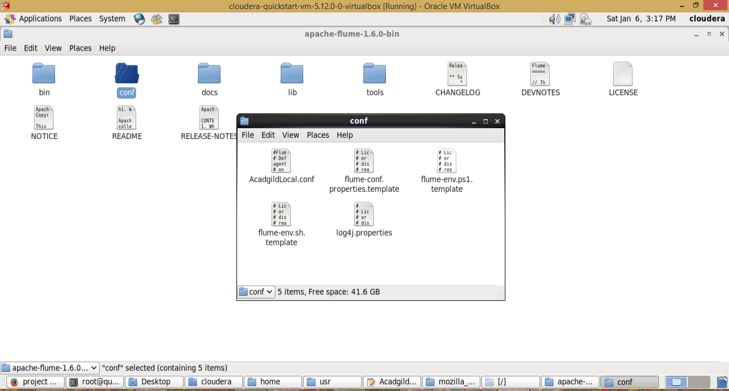

2. Modified the AcadgildLocal.conf with paths ( local flume and hdfs flume paths)

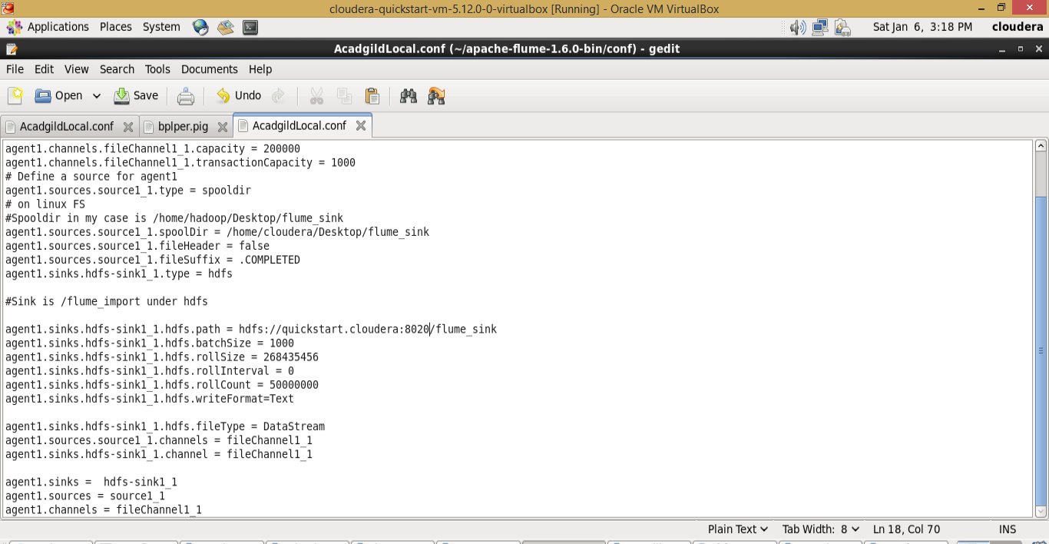

- Created a directory on desktop with name flume_sink and copied the xml file

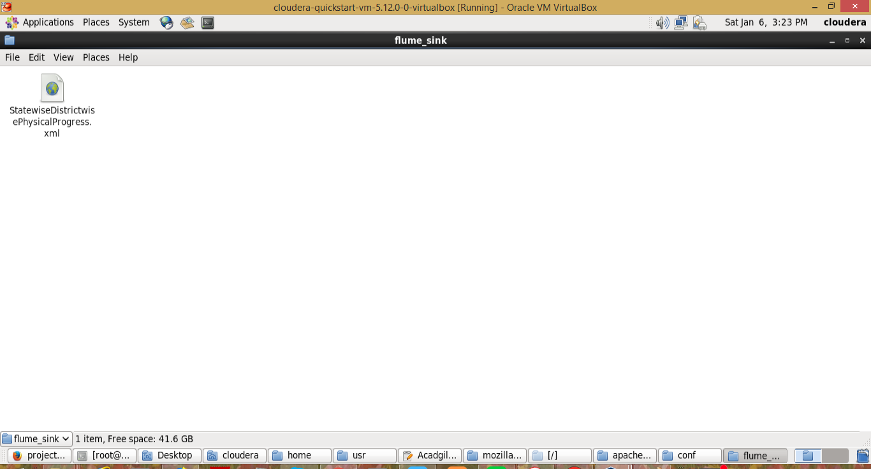

- hdfs created a empty folder flume_sink and given 777 permission
>hdfs dfs -mkdir /flume_sink
>hdfs dfs -chmod 0777 /flum_sink

- Executed the flume command

flume-ng agent -n agent1 -f /home/cloudera/apache-flume-1.6.0-bin/conf/AcadgildLocal.conf

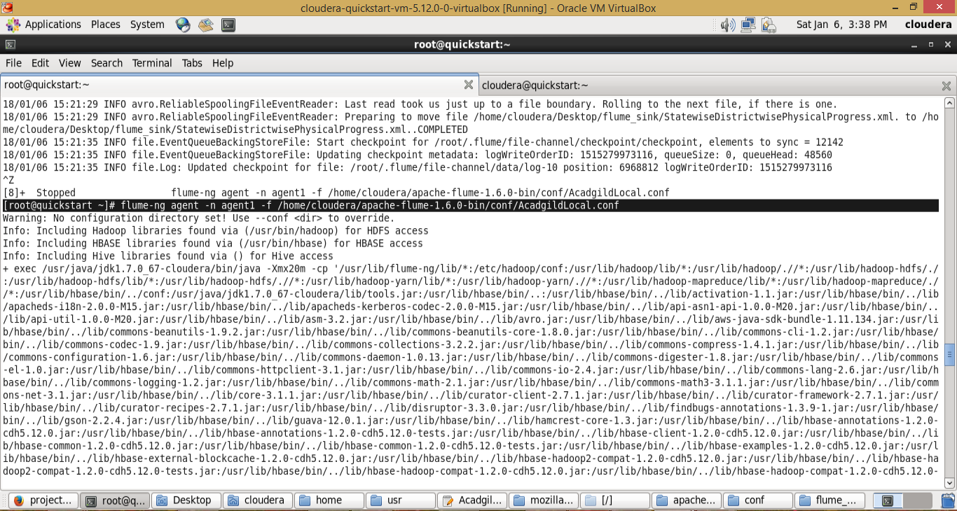

6. Flume successfully created the file on hdfs and modified the desktop xml file

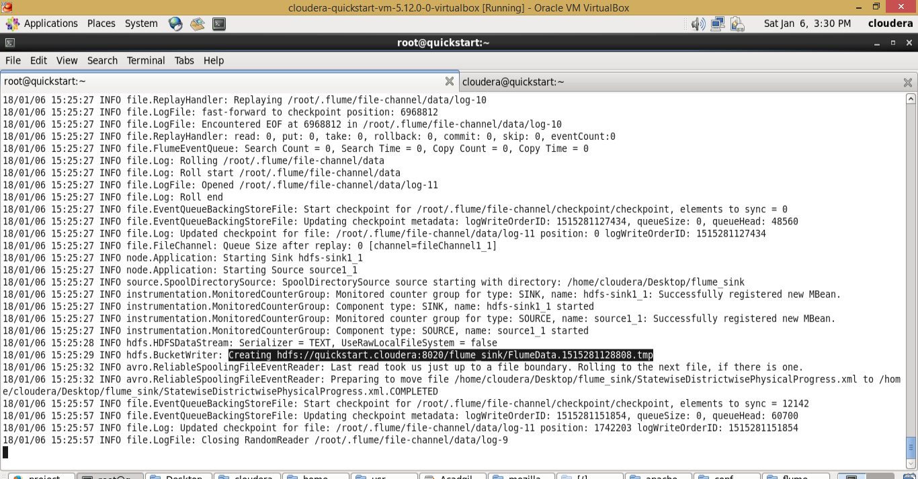

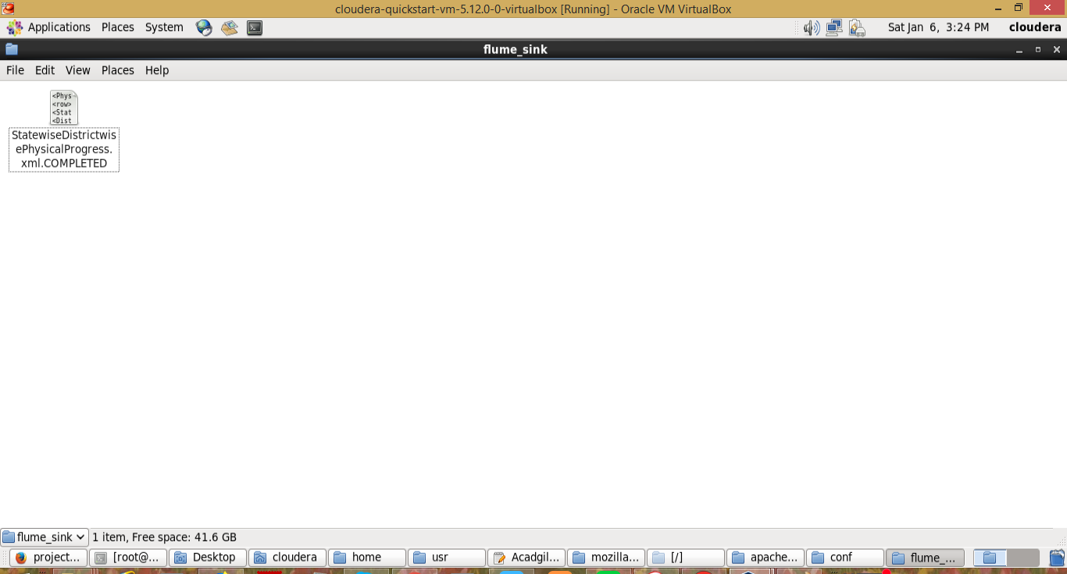

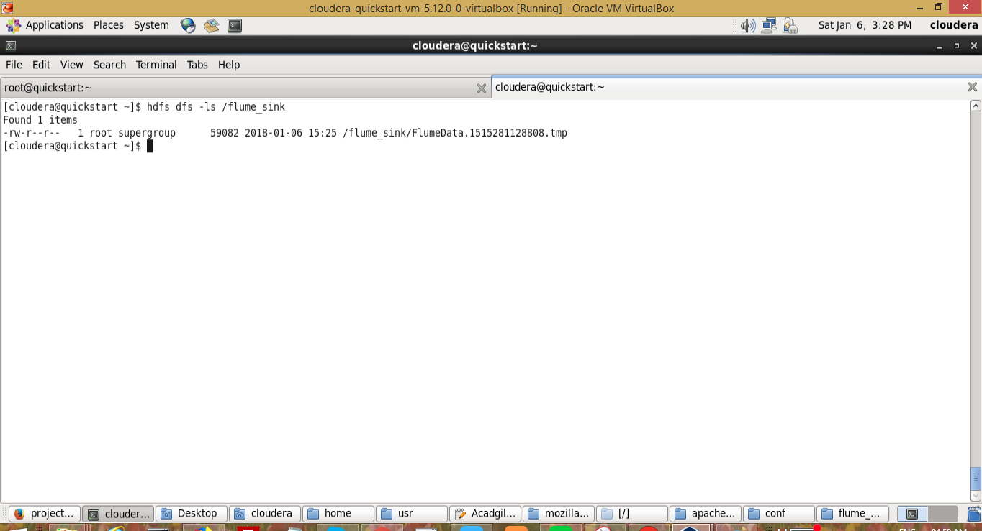

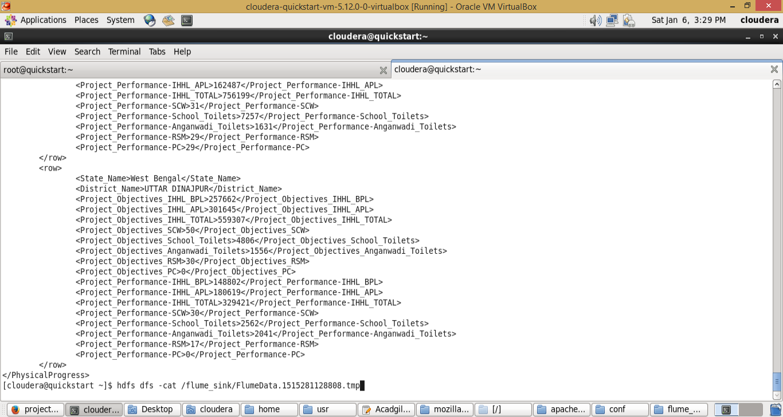

In this way local xml file is moved to hdfs fulme_sink folder and its name is
FlumeData.1515281128808.tmp. And this file is used for pig processing in next step.

Step 2:
Input file is in the XML format use Map reduce or pig to parse the data and get the results for
the below problem statements.
4. Problem statement
1. Find out the districts who achieved 100 percent objective in BPL cards
Export the results to mysql using sqoop

Created a parsexml.pig file to parse the xml and process the data

REGISTER '/home/cloudera/project2/piggybank.jar';

DEFINE XPath org.apache.pig.piggybank.evaluation.xml.XPath();

A = LOAD 'hdfs://quickstart.cloudera:8020/flume_sink/FlumeData.1515281128808.tmp' using org.apache.pig.piggybank.storage.XMLLoader('row') as (x:chararray);

B = FOREACH A GENERATE XPath(x, 'row/State_Name'), XPath(x, 'row/District_Name'), XPath(x, 'row/Project_Objectives_IHHL_BPL'), XPath(x, 'row/Project_Objectives_IHHL_APL'), XPath(x, 'row/Project_Objectives_IHHL_TOTAL'), XPath(x, 'row/Project_Objectives_SCW'),
XPath(x, 'row/Project_Objectives_School_Toilets'),
XPath(x, 'row/Project_Objectives_Anganwadi_Toilets'), XPath(x, 'row/Project_Objectives_RSM')
, XPath(x, 'row/Project_Objectives_PC'), XPath(x, 'row/Project_Performance-IHHL_BPL'), XPath(x, 'row/Project_Performance-IHHL_APL')
, XPath(x, 'row/Project_Performance-IHHL_TOTAL')
, XPath(x, 'row/Project_Performance-SCW')
, XPath(x, 'row/Project_Performance-School_Toilets')
, XPath(x, 'row/Project_Performance-Anganwadi_Toilets')
, XPath(x, 'row/Project_Performance-RSM')
, XPath(x, 'row/Project_Performance-PC');

--dump B;

--describe B;

C = foreach B generate $1 as district, $2 as bpl_objective, $10 as bpl_performance;

D = filter C by bpl_objective == bpl_performance;

store D into 'hdfs://quickstart.cloudera:8020/user/project2/' using PigStorage(',');

Executed the file in mapreduce mode

pig -x mapreduce /home/cloudera/project2/parsexml.pig

It created a output file /user/project2/part-m-00000

hdfs dfs -cat /user/project2/part-m-00000

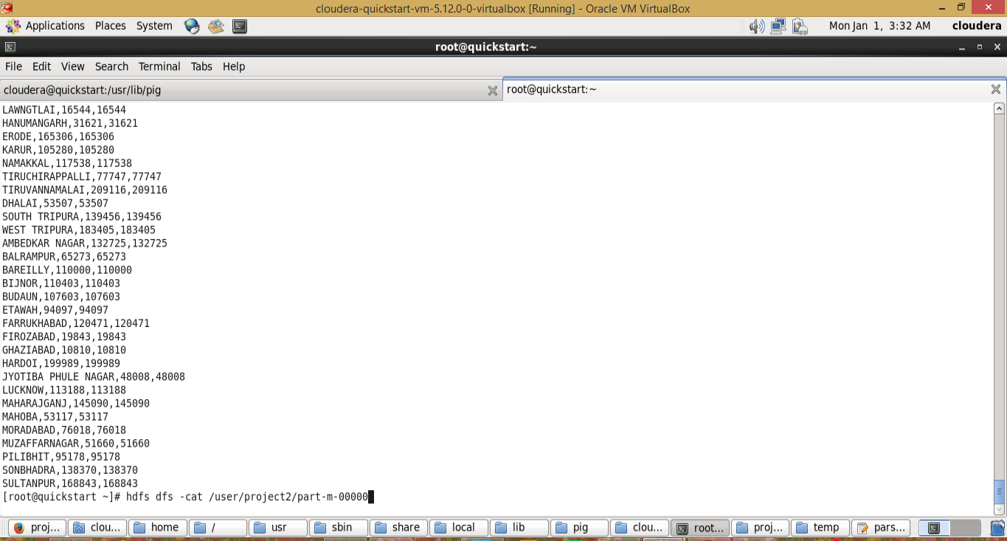

Provided 777 permission

hdfs dfs -chmod 0777 /user/project2/part-m-00000

mysql table created (project2) in school database and provided the access and commit

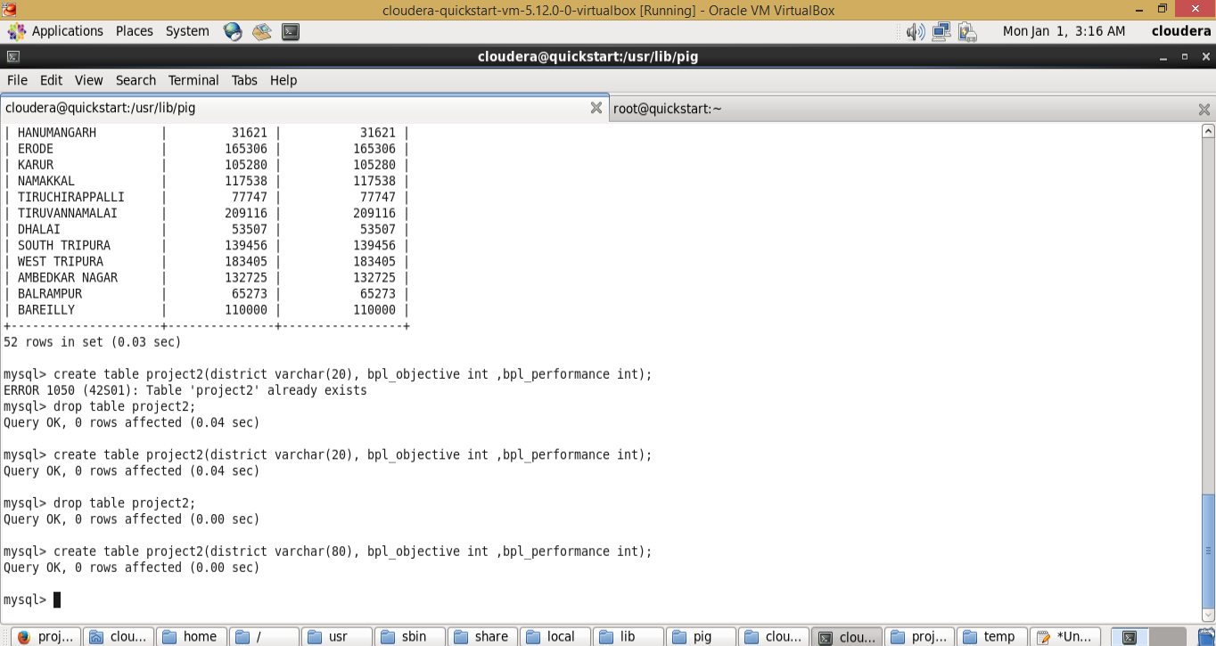

Using following sqoop command exported the pig output data to mysql project2 table

sqoop export --connect jdbc:mysql://localhost/school --username 'root' -P --table 'project2' --export-dir '/user/project2/part-m-00000' --input-fields-terminated-by ',' --columns district,bpl_objective,bpl_performance

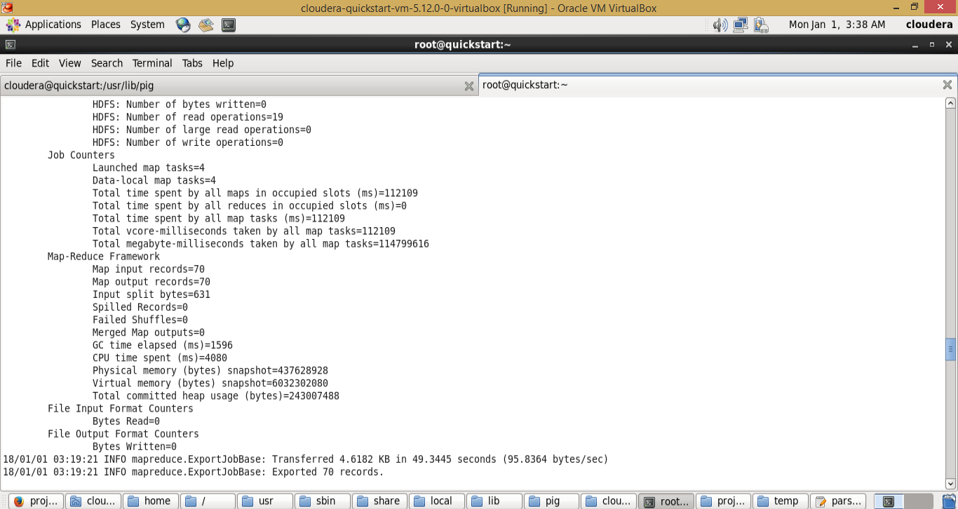

Data dump in mysql table

Select * from project2;

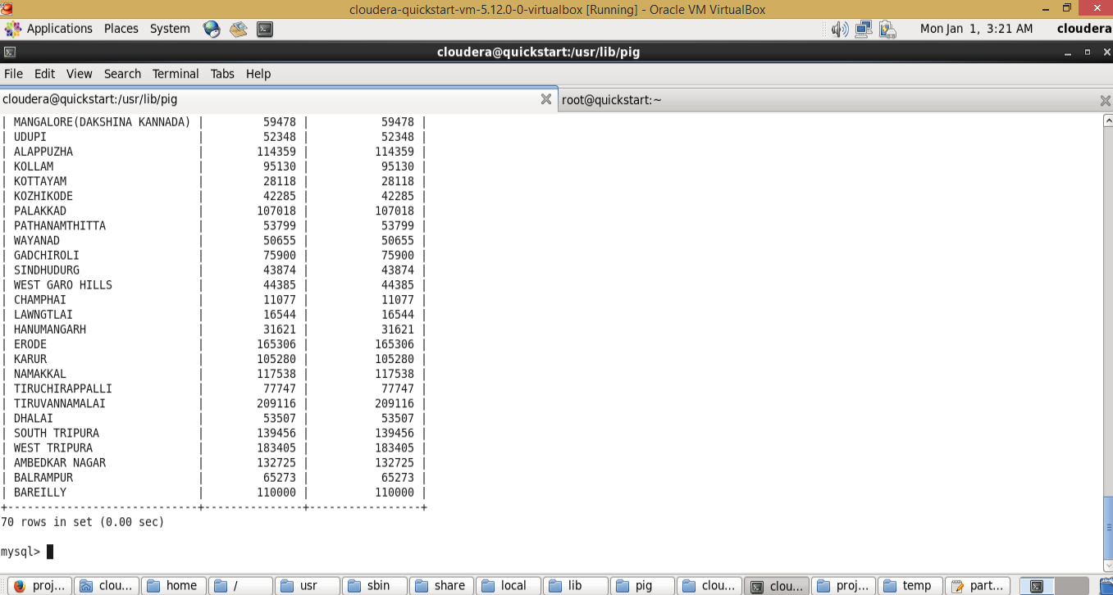

2. Write a Pig UDF to filter the districts which have reached 80% of objectives of BPL cards.
Export the results to MySQL using Sqoop.

Created tbe pig UDF to identify the districts which perform more than 80% in BPL

BPLPer.java
package bplpackage;

import java.io.IOException;

import org.apache.pig.EvalFunc;
import org.apache.pig.PigWarning;
import org.apache.pig.data.Tuple;

// Pow function to calculate the power of two numbers
public class BPLPer extends EvalFunc<Long> {

public Long exec(Tuple input) throws IOException {
try {

int bpl_objective = (int)input.get(0);
int bpl_performance = (int)input.get(1);
float bpl_percentage;

int result;

// System.out.println(bpl_objective);
// System.out.println(bpl_performance);

bpl_percentage = (( bpl_performance * 100) / bpl_objective);

//return (long) bpl_percentage;

//bpl_percentage = (int) bpl_percentage;

if(bpl_percentage >= 80){
result =1;
}else{
result = 0;
}

return (long) result;

} catch (Exception e) {
// Throwing an exception will cause the task to fail.
throw new IOException("Something bad happened!", e);
}
}
}

Created jar file and registered in bplper.pig file (bpl.jar)

Created a bplper.pig file to parse the xml and process the data

/* reading data from xml file */
REGISTER '/home/cloudera/project2/piggybank.jar';

DEFINE XPath org.apache.pig.piggybank.evaluation.xml.XPath();

A = LOAD 'hdfs://quickstart.cloudera:8020/flume_sink/FlumeData.1515281128808.tmp' using org.apache.pig.piggybank.storage.XMLLoader('row') as (x:chararray);

B = FOREACH A GENERATE XPath(x, 'row/State_Name'), XPath(x, 'row/District_Name'), XPath(x, 'row/Project_Objectives_IHHL_BPL'), XPath(x, 'row/Project_Objectives_IHHL_APL'), XPath(x, 'row/Project_Objectives_IHHL_TOTAL'), XPath(x, 'row/Project_Objectives_SCW'),
XPath(x, 'row/Project_Objectives_School_Toilets'),
XPath(x, 'row/Project_Objectives_Anganwadi_Toilets'), XPath(x, 'row/Project_Objectives_RSM')
, XPath(x, 'row/Project_Objectives_PC'), XPath(x, 'row/Project_Performance-IHHL_BPL'), XPath(x, 'row/Project_Performance-IHHL_APL')
, XPath(x, 'row/Project_Performance-IHHL_TOTAL')
, XPath(x, 'row/Project_Performance-SCW')
, XPath(x, 'row/Project_Performance-School_Toilets')
, XPath(x, 'row/Project_Performance-Anganwadi_Toilets')
, XPath(x, 'row/Project_Performance-RSM')
, XPath(x, 'row/Project_Performance-PC');

--dump B;

--describe B;

C = foreach B generate $1 as district, $2 as bpl_objective, $10 as bpl_performance;

store C into 'hdfs://quickstart.cloudera:8020/user/project3/' using PigStorage(',');
/* save the output to project3 folder of hdfs */

/* reading data from project3 folder */

REGISTER '/home/cloudera/project2/bpl.jar';

DEFINE bpl_percentage bplpackage.BPLPer;

D = LOAD 'hdfs://quickstart.cloudera:8020/user/project3/part-m-00000' using PigStorage(',');

E = foreach D generate (chararray)$0 as district, (int)$1 as bpl_objective, (int)$2 as bpl_performance;

dump E;

F = foreach E generate district, bpl_objective,bpl_performance, bpl_percentage(bpl_objective, bpl_performance);

dump F;

G = filter F by $3==1;

dump G;

store G into 'hdfs://quickstart.cloudera:8020/user/project4/' using PigStorage(',');

/* store the final output in project4 folder. */

Pig -x mapreduce /home/acadgild/project2/bplper.pig

Output is saved to hdfs project4 folder.

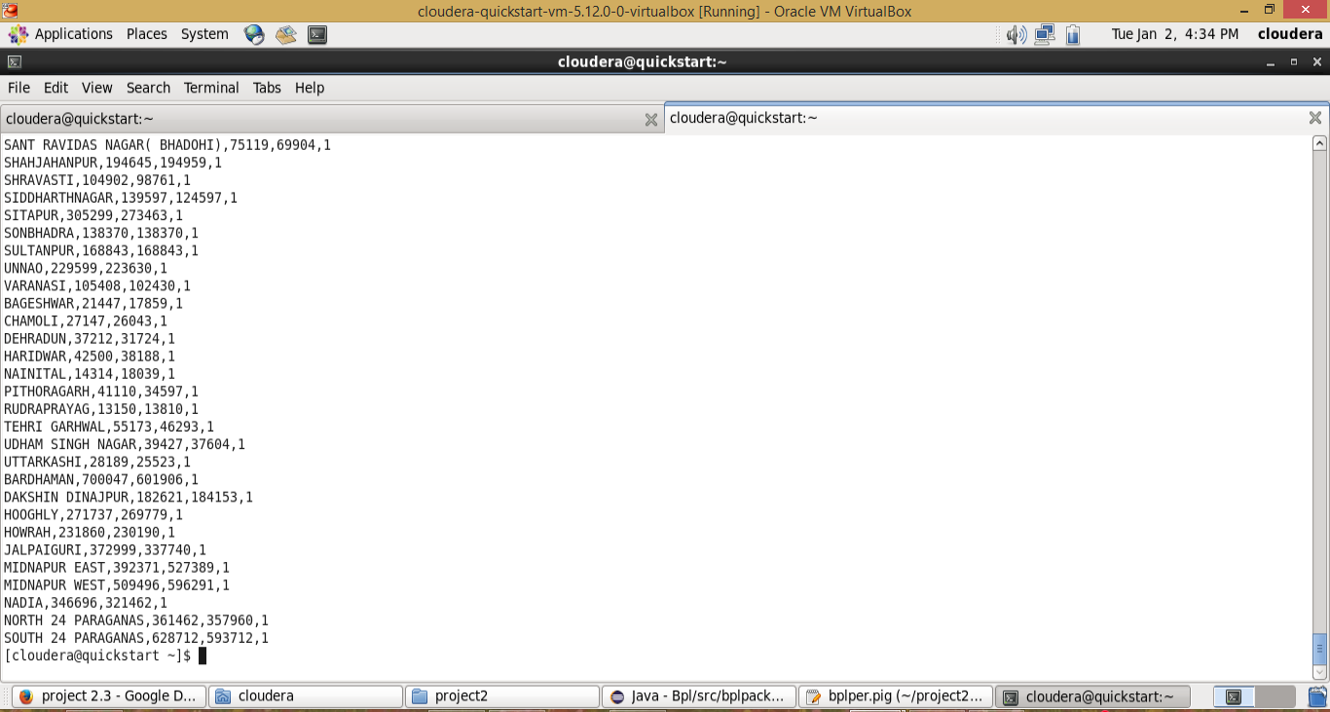

Now mysql table (project3) created.

Use database school;

create table project3(district varchar(200), bpl_objective int(11), bpl_performance int(11), status int(11));

grant all on *.* to ‘root’@’localhost’ with grant option;

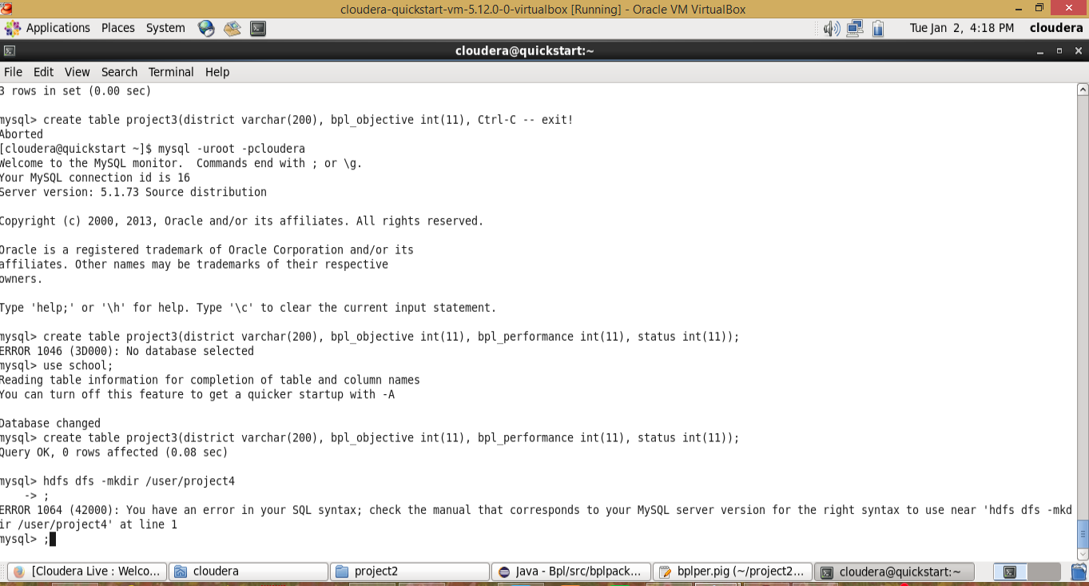

And following sqoop command data is copied to project3 table.

sqoop export --connect jdbc:mysql://localhost/school --username 'root' -P --table 'project3' --export-dir '/user/project4/part-m-00000' --input-fields-terminated-by ',' --columns district,bpl_objective,bpl_performance,status

